HDFS Practical Assignment – I
PART 1
- Task 1 — Set Up Local and HDFS Directories
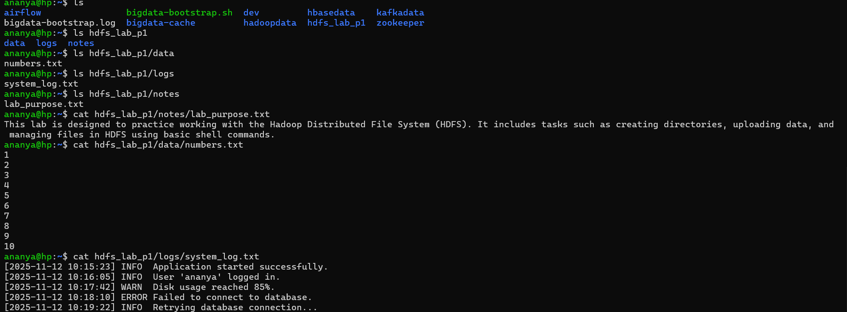
Local Directory Tree – Description
My local workspace hdfs_lab_p1 contains three well-organized subfolders, each serving a specific purpose for the HDFS practice lab:
- notes/ — This folder stores documentation files. In the screenshot, it contains lab_purpose.txt, which briefly explains the objective of the lab, including practicing directory creation, uploading data, and managing files in HDFS.
- data/ — This folder holds simple datasets used for uploading and testing in HDFS. The file numbers.txt contains a sequence of numbers from 1 to 10, serving as a sample structured dataset.
- logs/ — This folder includes mock log files for simulating real-world system logs. The file system_log.txt contains entries with various log levels such as INFO, WARN, and ERROR to mimic application behavior.

- Task 2 — Upload and Organize Data in HDFS
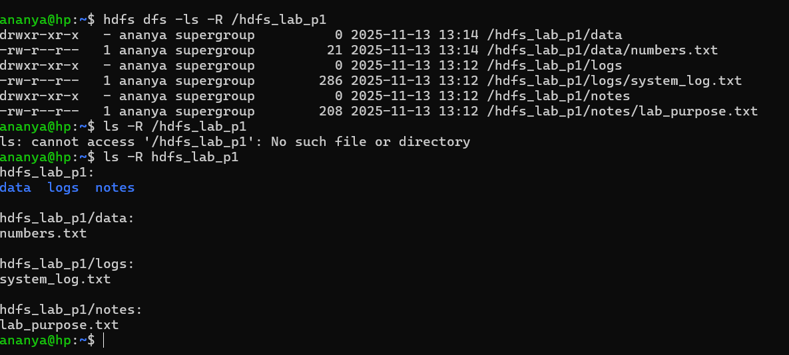

- Task 3 — Manage Files in HDFS

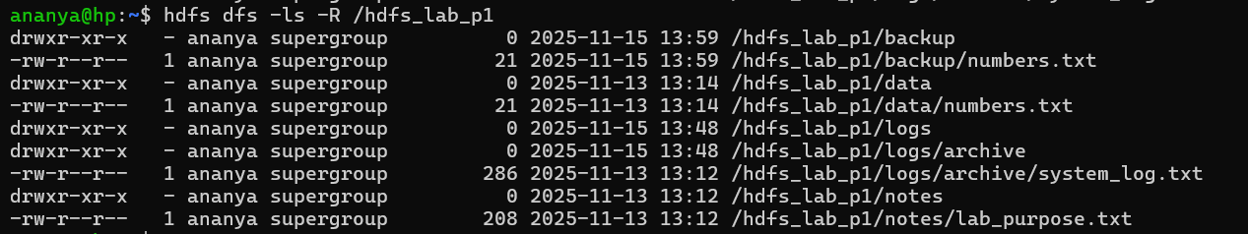

- The file system_log.txt was moved from /logs into the /archive directory to simulate log archival.
- The file lab_purpose.txt was copied into the /backup directory to provide redundancy and ensure data integrity.

- Task 4 — Clean-Up and Verification
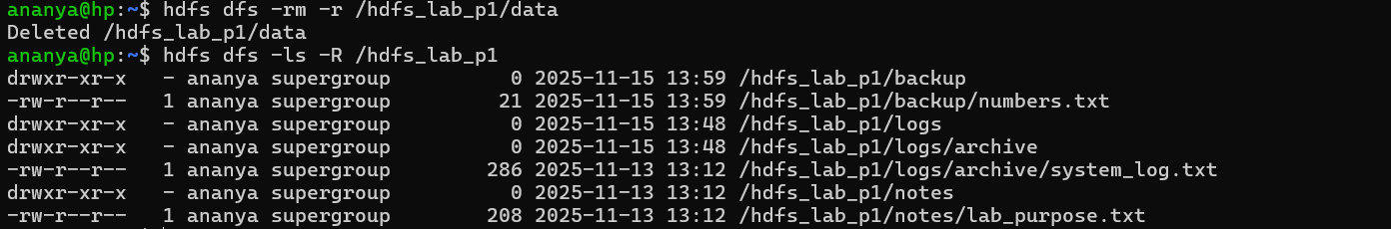

PART-2
- Task 5 — Replication Behavior Analysis
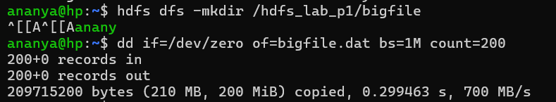
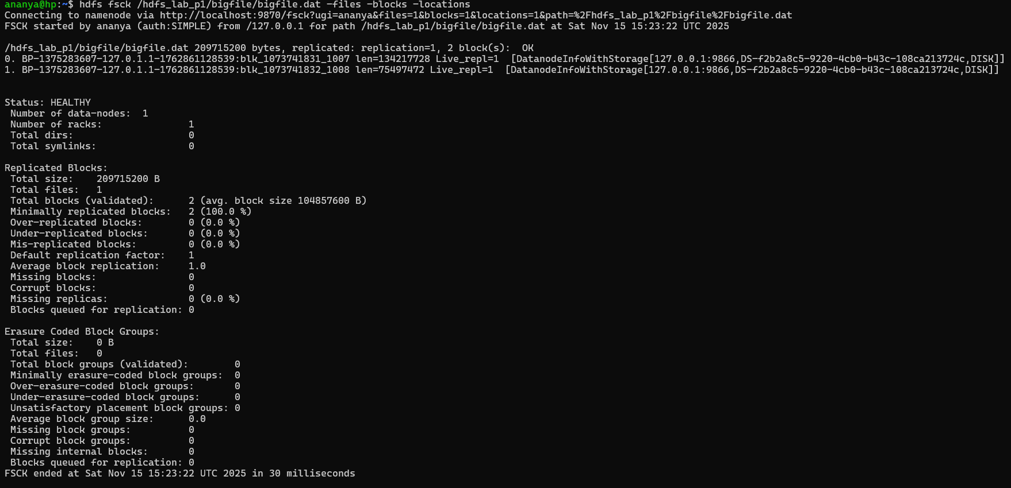
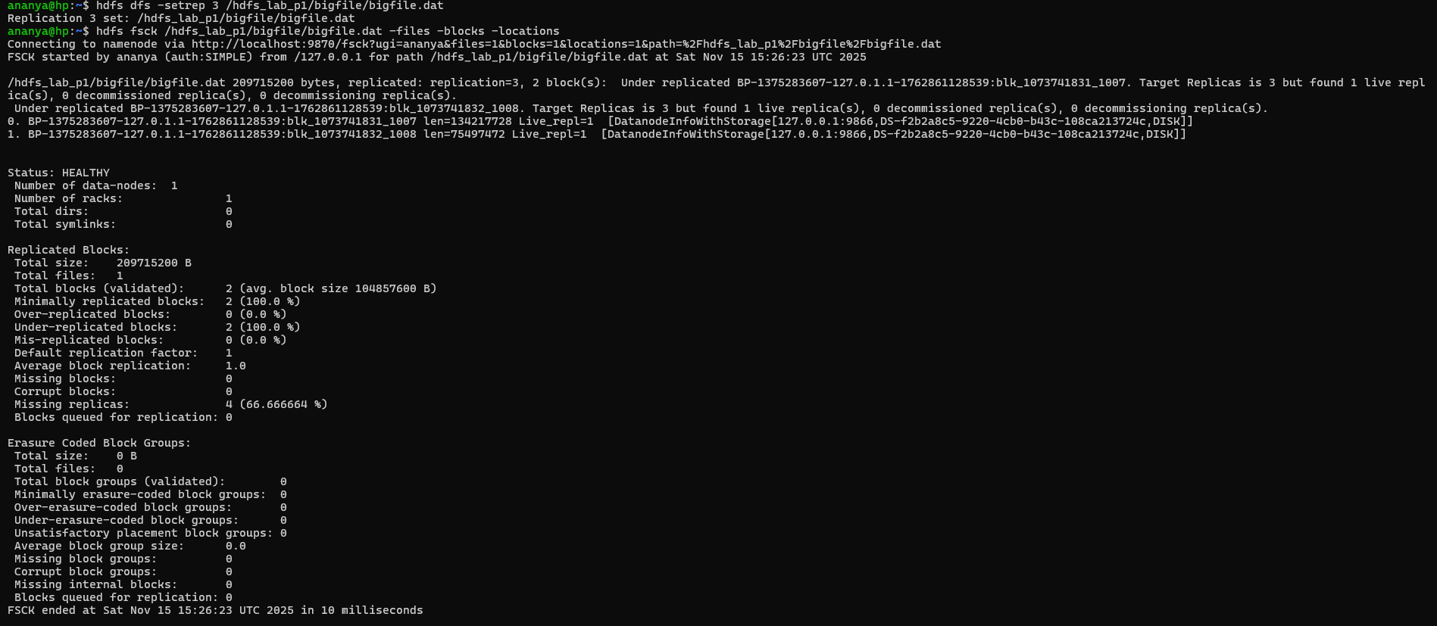

The replication report shows that several blocks are under-replicated because the configured replication factor 3 exceeds the number of available DataNodes in the cluster i.e, 1. In a single-node setup, HDFS cannot place additional replicas on other nodes, so it marks those blocks as under-replicated.
- Task 6 — Cluster Health and Storage Report
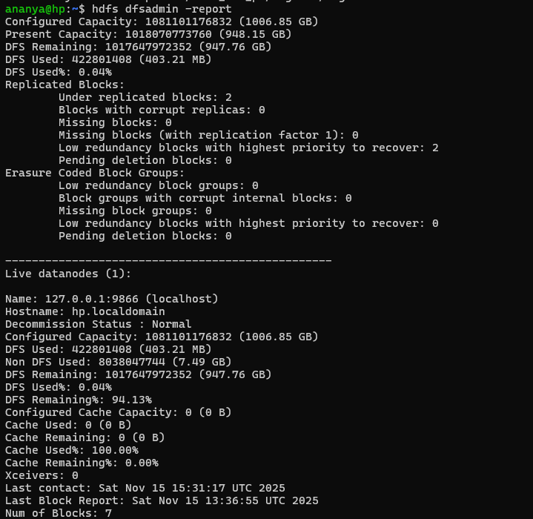

The HDFS cluster report shows a Configured Capacity of 1006.85 GB, which represents the total storage available in the cluster from the single active DataNode. Out of this capacity, only 403.21 MB is used, indicating that the stored data occupies a very small portion of the system. The DFS Remaining value of 947.76 GB confirms that most of the storage is still free and the cluster is operating with ample space. The report also highlights 2 under-replicated blocks, which occurs because the cluster has only one DataNode, making it impossible for HDFS to create additional replicas when the replication factor is set higher than one

